Navidrom Last.fm API Instruction

- Run navidrome

docker run -d \
--name navidrome \
-p 4533:4533 \
-v navidrome_data:/data \
deluan/navidrome

- Browser
http://localhost:4533

- Create Adim

- Check API
http://localhost:4533/rest/ping.view?u=YOUR_USERNAME&p=YOUR_PASSWORD&v=1.16.1&c=test&f=json

- Make a Last.fm API key
https://www.last.fm/api/account/create
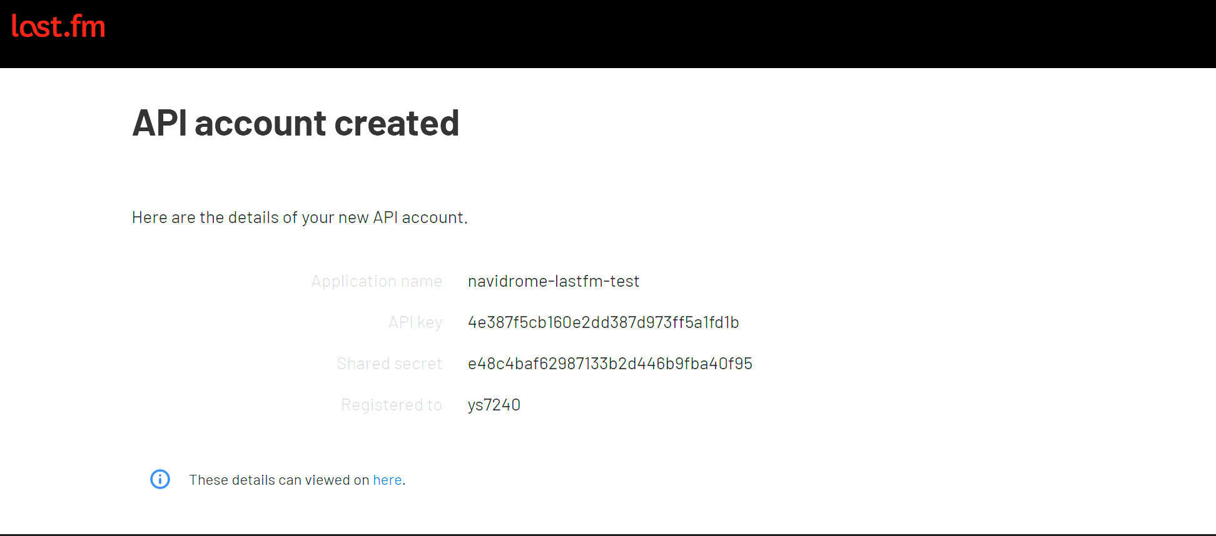

- API test (method = getrecenttracks)
https://ws.audioscrobbler.com/2.0/?method=user.getrecenttracks&user=YOUR_LASTFM_USERNAME&api_key=YOUR_API_KEY&format=json

- API test (method = getTopTracks)
https://ws.audioscrobbler.com/2.0/?method=user.getTopTracks&user=YOUR_LASTFM_USERNAME&api_key=YOUR_API_KEY&format=json

- How to connect Last.fm to Navidrome

- Stop the existing container
docker stop navidrome
docker rm navidrome

- Run a new container with LastFM API key
docker run -d \
--name navidrome \
-p 4533:4533 \
-v navidrome_data:/data \
-e ND_LASTFM_APIKEY=YOUR_API_KEY \
-e ND_LASTFM_SECRET=YOUR_SHARED_SECRET \
deluan/navidrome

- Scrobble to Last.fm
